Jaypee Institute of Information Technology, Noida
Sector-62


Project Report

Unified Cross Modal Audio-Visual Steganography Framework

Enrollment No. Name of Student
23103179 Shubhankar Kumar
23103170 Agnik Paul

Submitted to :- Vikash Sir

INDEX

- Introduction
- Problem Statement
- Objectives
- Proposed Solution / Methodology
- Tools and Technologies Used
- Features
- Outcomes
- Contribution to Sustainable Development Goals (SDGs) • Reference

INTRODUCTION

In today’s digital world, secure communication has become a major concern due to the rapid growth of the internet and data sharing platforms. Every day, a large amount of sensitive information such as personal details, passwords, business documents, and government data is transmitted through digital media. Protecting this information from unauthorized access is extremely important. Traditional security techniques like encryption protect the content of the message, but they do not hide the existence of the message itself. This is where steganography plays an important role.

Steganography is the art and science of hiding secret information inside another non-secret file such as an image, audio, or video file in such a way that no one can even suspect the presence of hidden data. Unlike encryption, which makes the data unreadable, steganography hides the data completely from visibility. This technique is widely used in secure communication, digital watermarking, copyright protection, confidential data transmission, and cyber forensics.

The project titled “Steganography Analyzer – Image and Audio Data Hiding System” is designed to provide a practical and secure method for hiding secret messages inside PNG images and WAV audio files using the Least Significant Bit (LSB) technique. The system also supports AES-based encryption to provide an additional layer of security. By combining steganography with cryptography, the project ensures double protection of sensitive information.

This project also includes a user-friendly graphical interface that allows users to easily encode and decode messages without requiring deep technical knowledge. It helps students understand the practical implementation of steganography, binary operations, digital image processing, and secure data hiding techniques. The main aim of this project is to demonstrate how secret communication can be achieved safely and efficiently using modern cybersecurity concepts.

PROBLEM STATEMENT
With the rapid advancement of digital technology and the widespread use of the internet, the transmission of sensitive information through digital media has increased significantly. Personal data, confidential business documents, medical records, and government information are constantly being shared online. While encryption techniques are widely used to protect the content of data, they still reveal the presence of secret communication, which can attract attackers. This creates a major challenge in ensuring complete security and privacy of digital information.
Traditional data protection methods focus mainly on encryption, but they do not provide a solution for hiding the existence of the message itself. As a result, encrypted data can still become a target for hackers, surveillance systems, and cyber attackers. In many real-world scenarios, simply encrypting data is not sufficient because the detection of secret communication alone can lead to serious security risks.
There is a strong need for a secure and reliable system that not only protects sensitive information but also hides the fact that such information is being transmitted. Steganography provides a powerful solution by embedding secret data inside digital media such as images and audio files in a way that is not noticeable to human senses.
However, many existing steganography tools are either too complex for beginners, lack proper security features like encryption, or do not support multiple media formats. Therefore, the problem addressed by this project is the lack of a simple, secure, and user-friendly steganography system that supports both image and audio-based data hiding with strong encryption.
This project aims to solve this problem by developing a Steganography Analyzer that allows users to securely hide and extract secret messages using LSB-based image and audio steganography combined with AES encryption and a graphical user interface for easy usage.

OBJECTIVES

The main objectives of the Steganography Analyzer – Image and Audio Data Hiding System are as follows:

To design and develop a secure steganography system
To create a secure application that can hide secret messages inside digital media such as images and audio files to ensure safe communication.

To implement LSB-based image steganography
To use the Least Significant Bit technique for embedding secret data inside PNG images without causing any visible change to the original image.

To implement audio steganography using WAV files
To hide confidential information inside WAV audio files using LSB manipulation in such a way that no audible distortion is produced.

To provide double-layer security using encryption
To encrypt the secret message using AES-based encryption before embedding it into the image or audio file for enhanced data security.

To develop a user-friendly graphical interface
To design an easy-to-use graphical user interface that allows users to perform encoding and decoding operations without requiring deep technical knowledge.

To support secure message extraction
To ensure that the original secret message can be accurately and safely recovered from the stego-image or stego-audio file.

To improve cybersecurity awareness and learning
To help students understand the concepts of steganography, cryptography, binary operations, and secure data handling through a practical implementation.

To ensure efficient performance and data integrity
To achieve fast encoding and decoding operations while maintaining the originality and quality of the carrier image and audio files.

PROPOSED SOLUTION / METHODOLOGY

The system first takes a secret message as input from the user. For enhanced security, the message is encrypted using AES-based symmetric encryption before the steganography process begins. This encrypted message is then converted into binary form so that it can be embedded inside digital media using the Least Significant Bit technique.

In the Image Steganography Module, the user selects a PNG image as the carrier file. The selected image is converted into a pixel array using image processing techniques. The binary form of the encrypted message is embedded into the least significant bits of the RGB values of the image pixels. Since only the last bit of each pixel is modified, the visual appearance of the image remains unchanged. After successful embedding, a stego-image is generated and saved.

In the Audio Steganography Module, the user selects a WAV audio file as the carrier file. The audio samples are extracted and converted into a numerical array. The encrypted binary data is then embedded into the least significant bits of the audio samples. As the change in amplitude is very small, the human ear cannot detect any difference in sound quality. The modified audio is saved as a stego-audio file.

For decoding, the system follows a reverse process. The user selects the stego-image or stego-audio file. The system extracts the least significant bits from the file to retrieve the embedded binary data. This binary data is then converted back into encrypted text and finally decrypted using the same user password to recover the original secret message.

The entire application is developed using Python programming language. Libraries such as Pillow and NumPy are used for image processing, SciPy and Wave modules are used for audio processing, and PyCryptodome is used for AES encryption and decryption. Tkinter is used to design the graphical user interface, which allows users to easily perform encoding and decoding operations through simple buttons and input fields.

Multithreading is used to ensure that the graphical interface remains responsive during the encoding and decoding process. Input validation and error handling mechanisms are applied to prevent invalid file selection and incorrect decoding attempts. This complete methodology ensures that the system provides secure, efficient, and reliable steganography functionality.

TOOLS AND TECHNOLOGIES USED

• Python 3.12
• Pillow (PIL)
• NumPy
• SciPy
• Wave Module
• PyCryptodome
• Tkinter
• Threading Module
• Visual Studio Code

FEATURES
- Image Steganography (PNG)
  - Hide secret text messages inside PNG images
  - Extract hidden messages from stego-images
  - LSB (Least Significant Bit) substitution technique
  - Visually identical output (no visible changes)
  - Capacity calculation before encoding
  - Supports large messages (up to ~777 KB for 1920×1080 images)
- Audio Steganography (WAV)
  - Embed messages in WAV audio files
  - Extract messages from stego-audio
  - Two embedding modes:
    - Sequential: Hides data in consecutive samples
    - Key-based: Randomizes positions using secret key
  - Inaudible modifications (LSB changes only)
  - Capacity calculation (e.g., ~330 KB for 60-second audio)
- AES-256 Encryption (Image Only)
  - Optional message encryption before embedding
  - 256-bit AES encryption in CBC mode
  - Password-protected encryption/decryption
  - Double-layer security: encrypted + hidden
  - SHA-256 key derivation
- Graphical User Interface (GUI)
  - User-friendly desktop application
  - Tabbed interface (Image / Audio)
  - File selection dialogs
  - Real-time capacity display
  - Text input/output areas
  - Clear button to reset fields
  - Status bar for feedback
- File Validation
  - Automatic format checking
  - PNG validation for images
  - WAV validation for audio
  - File size validation
  - Error messages for invalid files
- Capacity Management
  - Automatic capacity calculation
  - Real-time capacity display after file selection
  - Message size validation
  - Prevents oversized messages
  - Shows capacity in bytes and characters
- Key-Based Position Randomization (Audio)
- Optional secret key for audio embedding
- SHA-256-based position generation
- Pseudo-random sample selection
- Enhanced security through obscurity
- Same key required for encoding/decoding
- Binary Operations
- Text to binary conversion
- Binary to text conversion
- Bit manipulation (LSB extraction/modification)
- Efficient byte array handling
- Background Processing
- Multi-threaded encoding/decoding
- Non-blocking GUI during operations
- Responsive interface
- Progress indicators
- Error Handling
- Comprehensive error checking
- User-friendly error messages
- Input validation
- Graceful failure recovery
- Detailed error descriptions

OUTCOMES

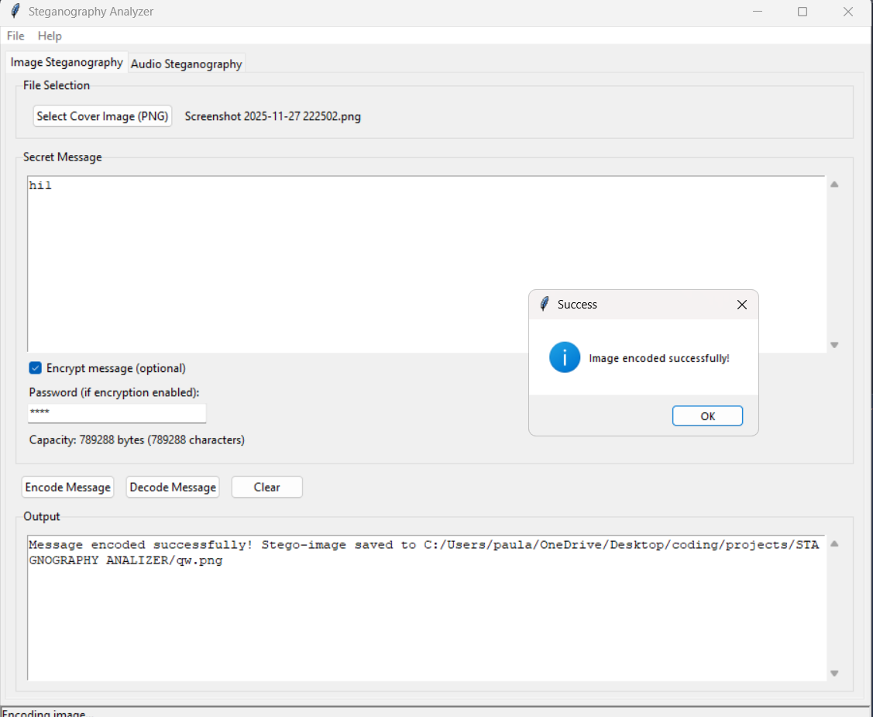
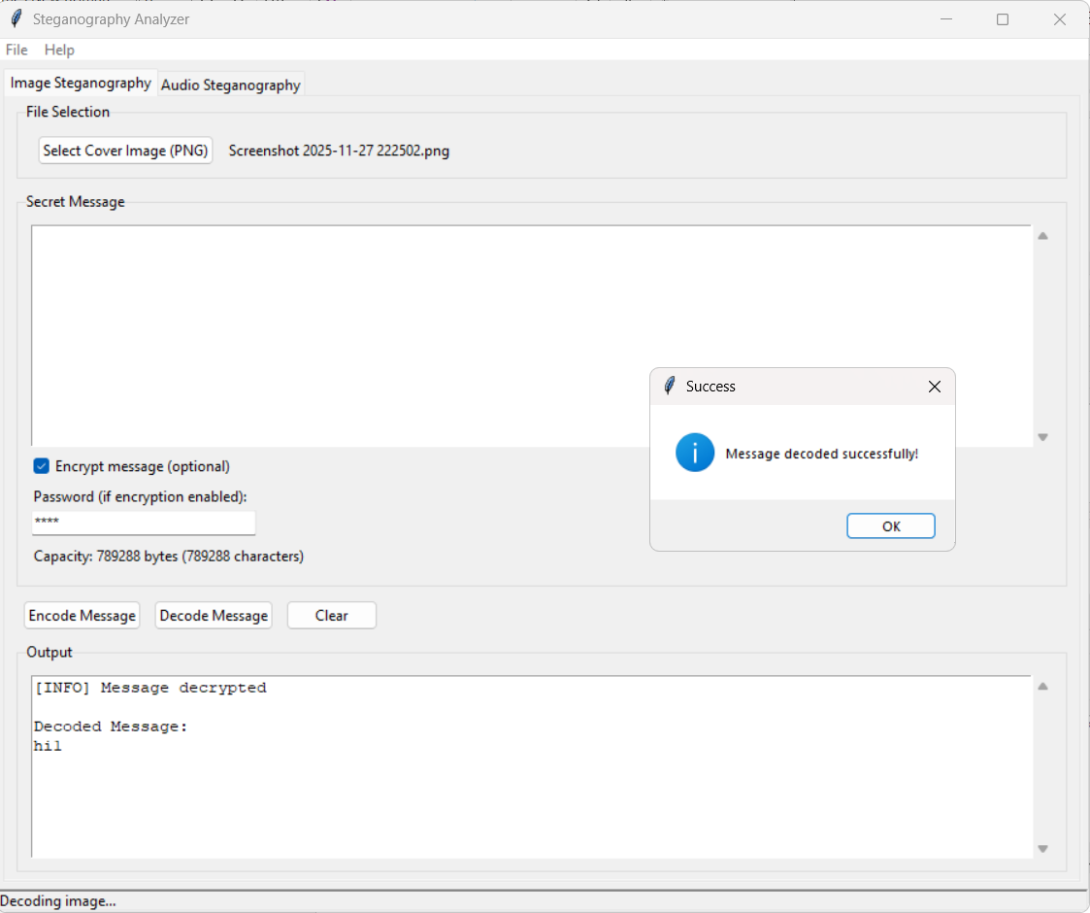

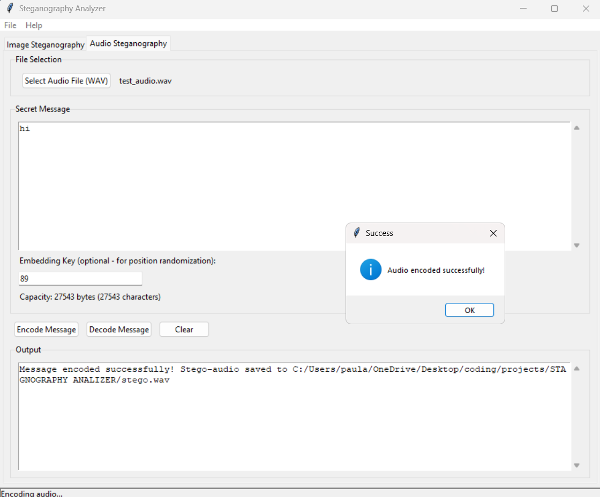

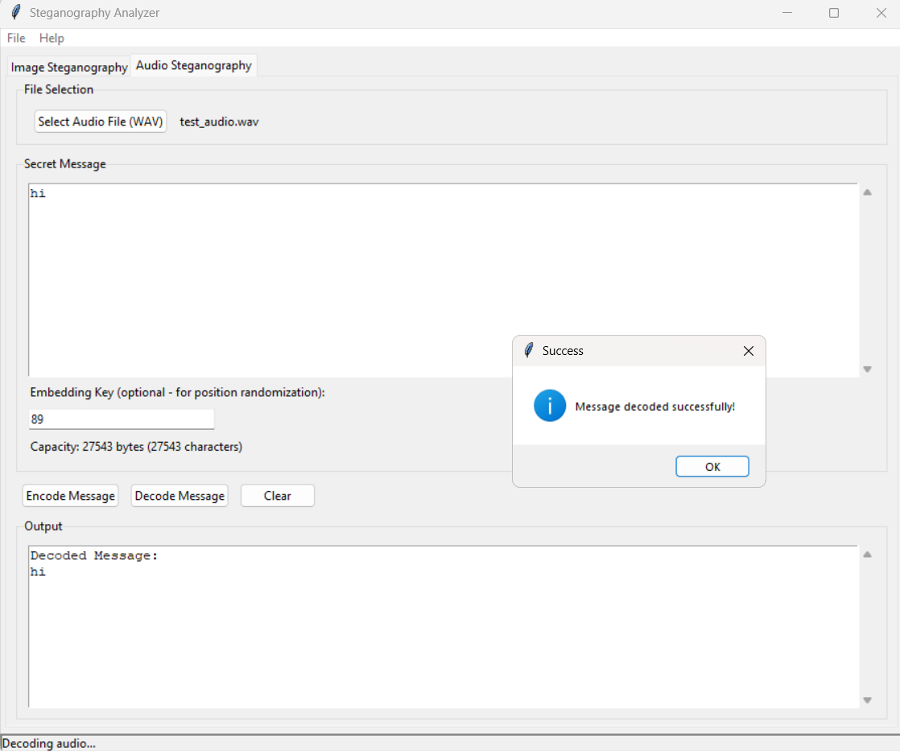

REAL LIFE APPLICATIONS

  - Secure Communication
  - Digital watermarking
  - Anti-counterfeiting
  - Confidential Data Transmission
  - Personal Use
  - Journalism and media

CONCLUSION

The Steganography Analyzer – Image and Audio Data Hiding System successfully demonstrates a secure and efficient technique for hiding confidential information inside digital media files. This project combines steganography and cryptography to provide double-layer security, ensuring that the secret message is not only hidden but also encrypted for enhanced protection. By using the Least Significant Bit technique for both image and audio steganography, the system is able to embed data without causing any noticeable change in the original image or audio quality.

The project fulfills its objective of developing a user-friendly and reliable application that allows users to encode and decode secret messages easily through a graphical interface. The use of PNG images and WAV audio files ensures that data is preserved accurately without loss during transmission. Additionally, the integration of AES-based encryption strengthens the overall security of the system.

This project also provides strong educational value by helping students understand important concepts such as data hiding, binary operations, image and audio processing, encryption, and secure communication. The Steganography Analyzer proves to be an effective solution for secure and covert data transmission and demonstrates how modern cybersecurity techniques can be applied to real-world digital communication systems.

REFERENCES USED

1. Python Official Documentation – https://docs.python.org/3/
2.Pillow (PIL) Image Processing Library – https://pillow.readthedocs.io/
3.NumPy Official Documentation – https://numpy.org/doc/
4.SciPy Documentation (Audio Processing) – https://docs.scipy.org/doc/scipy/
5. PyCryptodome Cryptography Library – https://www.pycryptodome.org/
6.AES Encryption Standard – https://nvlpubs.nist.gov/nistpubs/FIPS/NIST.FIPS.197.pdf
7.PBKDF2 Key Derivation – https://www.ietf.org/rfc/rfc2898.txt
8. SHA-256 Hash Algorithm – https://nvlpubs.nist.gov/nistpubs/FIPS/NIST.FIPS.180-4.pdf
9. Tkinter GUI Documentation – https://docs.python.org/3/library/tkinter.html
10.LSB Steganography Concept – https://www.geeksforgeeks.org/image-based-steganography-using-python/

